*Introducing....*

**The Model DDX –Wet/Dry** - ***A New Generation***

|  |  |  |
| --- | --- | --- |
| Valve Size | DDX -W/D  **Valve Height**  Including Control Valve | Model D/Model E Alternate  **Valve Height**  including Control Valve and Block Piece |
| 4” (100mm) | 471mm | 954mm |
| 6” (165mm) | 554mm | 1078mm |

**A combination grooved end alternate valve offering both Wet and Dry configurations, the New DDX-W/D provides an alternative to the Model E / Model D Flanged Alternate valve in one single valve.**

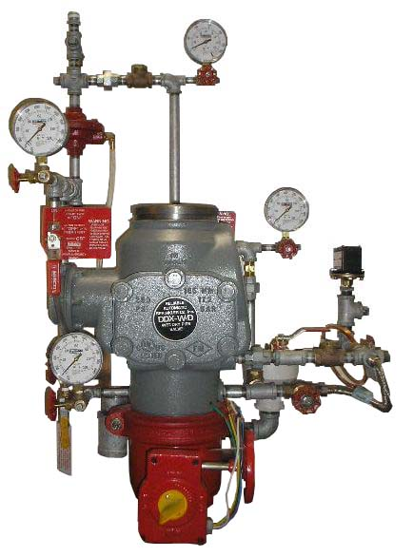

**Key Benefits:**

* Less than half the height of the Reliable Model E/Model D Flanged Alternate valve
* Lighter user friendly grooved end design
* Simple single lever change over
* External reset knob provides for fast system testing & easy maintenance
* Simplified trim configuration also saves space around the valve
* Available as a fully assembled valve station
* Optional Reliable Model B Accelerator and Trim Kit available on all sizes
* Incorporates the Model LP Dry Valve Actuator, resulting in lower air pressure requirements
* Sizes available: 4” (100mm) and

6” (165mm)

**New DDX-W/D versus Flanged Alternate Valve**

|  |  |  |  |  |
| --- | --- | --- | --- | --- |
| Nominal O/A  Trim Dimensions | 4”DDX-W/D | 4” Alternate  Model D/Model E | 6” DDX-W/D | 6” Alternate  Model D/Model E |
| Height | 1119mm | 1050mm | 1196mm | 1140mm |
| Width | 700mm | 1010mm | 700mm | 1010mm |
| Depth | 375mm | 550mm | 426mm | 600mm |
| Weight | 70kg | 150kg | 90kg | 185kg |

**Footprint with Standard Trim (without Model B Accelerator)**



**Atkinsons Way, Foxhills Industrial Estate, Scunthorpe, North Lincolnshire, DN15 8QJ**

**Tel: 01724 854199 Fax: 01724 854213**

**E-mail:** [sale@fireprotectioncentre.com](mailto:sale@fireprotectioncentre.com)

**Web:** [www.fpcdatacentre.co.uk](http://www.fpcdatacentre.co.uk)

Fire Protection &

Flow Control Products

Atkinsons Way, Foxhills Industrial Estate, Scunthorpe, North Lincolnshire, DN15 8QJ

Tel: 01724 854199 Fax: 01724 854213

E-mail: [sale@fireprotectioncentre.com](mailto:sale@fireprotectioncentre.com) Web: [www.fpcdatacentre.co.uk](http://www.fpcdatacentre.co.uk)